Annual Examination (2023-24)
Class: XI [Physical Education] Date: 5/03/2024 Time: 3 Hrs MM: 70
General instructions:
- The Question paper consists of 5 Section and 37 Questions.
- Section A consists of questions 1-18 carrying 1Marks each and is multiple choice questions. All questions are compulsory.
- Section B consists of questions 19-24 carrying 2 marks each and is very short answer type and should not exceed 60-90 words. Attempt any 5.
- Section C consists of questions 25-30 carrying 3 marks each and is short answer type and should not exceed 100-150 words. Attempt any 5.
- Sections D consists of questions 31-33 carrying 4 marks each and are case study questions.
- Section E consists of questions 34-37 carrying 5 marks each and is short answer type and should not exceed 200-300 words. Attempt any 3.

SECTION—A
- The correct positioning of fingers in Anulom-Vilom is:
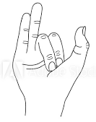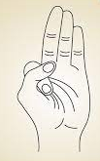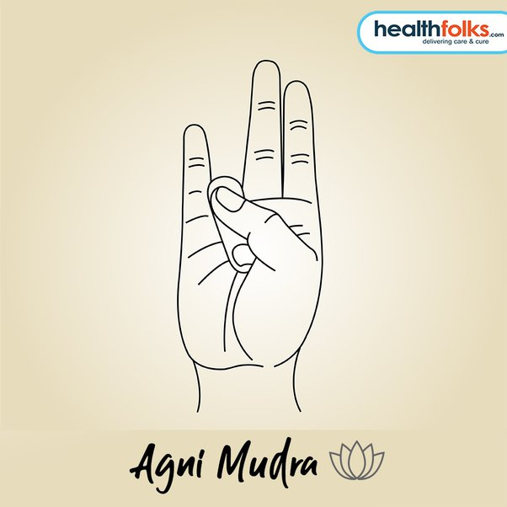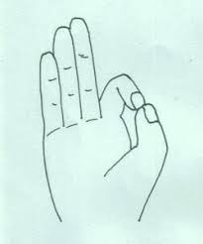
(a) (b) (c) (d)
- After competing D.P.Ed. you can teach Classes........................
  - I to VIII (b)I to V (c)VI to VIII (d)I to X
- How many components are included in Khelo India Program?
(a)10 (b)12 (c)8 (d)15
4. _______________is a very good Kriya to get rid of nasal allergy.
- Vastradhauti (b)Dandadhauti (c)Neti (d)Kapalbhati
- Given below are the two statements labeled Assertion (A) and Reason(R):
A:The heart, blood and blood vessels constitute as the circulatory system of the body.
R:Arteries carry blood away from the heart and veins carry blood back to the heart.
In the context of above two statements, which one of the following is correct?
  - Both(A) and (R) are true and (R) is the correct explanation of (A).
  - Both(A)and(R)are true, but (R) is not the correct explanation of (A).
  - (A)is true, but(R) is false.
  - (A) is false, but (R)is true.
- Qilaraipur sports festival was first held in:
(a)1930 (b)1931 (c)1932 (d)1933
- What is the maximum range of movement possible at a joint known as?
  - Flexibility (b)Coordinative ability (c)Locomotor ability (d)None of the above
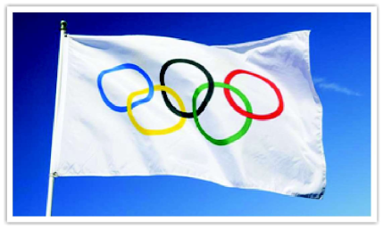
- Identify the following figure:
  - Olympic Flag (b)National Flag (c)Special Olympics Flag (d)None of these

- Match the following:
Column A | Column B
A.Wearable gear | (i)Natural grass
B.Playing Surface | (ii)Smart Watch
C. Protective Equipment | (iii)3D Lasers
D. Sensor Tools | (iv)Helmet

Option Code | A | B | C | D
a) | Iv | ii | i | iii
b) | I | ii | iii | iv
c) | Iii | iv | ii | i
d) | Ii | i | iv | iii
- Given below are the two statements labeled Assertion (A) and Reason(R):
A: Doping can be defined as the use of chemical substances, foreign to the body, to improve performance in competition, may be national or international.
R: Doping can have many harmful side effects.
In the context of above two statements, which one of the following is correct?
  - Both(A)and(R)are true and(R)is the correct explanation of(A).
  - Both(A)and (R) are true, but(R)is not the correct explanation of(A).
  - (A)is true, but (R) is false.
  - (A)is false, but (R)is true.
11. ……………………was defined as the study of motion?
a) Anatomy b) Physiology c) Kinesiology d) Psychology
- An individual’s ability to bounce back emotionally in the face of a diversity is referred as__________
- Aggression (b) Anxiety (c)Resilience (d)Motivation
- The first case of doping in Modern Olympics came to light in:
(a)1904 (b)1908 (c)1912 (d)1916
14. ____________is a person’s ability to control their body position relative to some support base.
- Inertia (b)Balance (c)Spin (d)None of the above
- The simplest possible joint movement is:
  - Circular motion (b)flexing movement (c) gliding movement (d)swinging motion
- Which of the following is a matter of inheritance?
  - Personality traits (b)Habits & routines (c)Character (d) Manners & etiquettes
- Which parameters are required for calculation of BMI?
  - Weight and Height (b)Age and Gender (c)Weight and Age (d)Height and Age
- The first modern Olympic games were held in the year........................
  - 1896 (b)1900 (c)1904 (d)None of the above

SECTION—B
- What do you mean by sports journalism?
- List the principles of Niyama.
- What is the main aim of Adaptive Physical Education?
- What is the formula for calculating waist-hip ratio?
- Define Abduction.
- What is meant by Team Cohesion?

SECTION—C
- Write in brief about the objectives of Physical Education.
- Briefly explain procedure of any two Pranayama techniques.
- Describe any two qualities of a good leader.
- What is physiology? Write its importance.
- Explain Kinetics and Kinematics.
- Explain Resilience and its importance in sports?

SECTION—D
- The kinds of jobs in Physical Education (PE) are changing because people care more about being healthy. PE isn’t just about gym class anymore – it’s about teaching good health habits and using technology to help. People understand better now how exercise helps our bodies and minds. The looks at how PE jobs are getting more diverse and important, making our lives healthier in different ways.

Based on the above, answer the following questions:
  - Courses prepares Physical Education Teachers for the elementary stage of school education i.e. for Classes I to VIII.
  - Those physical educators who have the talent for writing may opt a career in the newspapers & sports magazines as the...................... .
(c ) Traditionally, careers in physical education and sports have focused on..................and in schools, colleges and universities.
(d) A large number of sports channels like ESPN, Star Sports etc. need good sports for various sports events.
OR
(d) NCTE recognizes only courses for Physical Education Teachers.
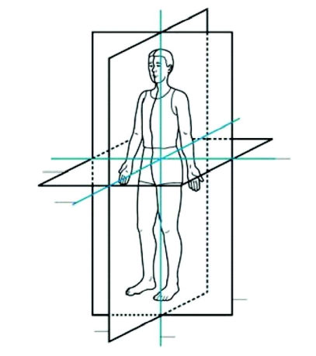
- To perform the daily activities, we need to change body positions or move our body parts as well as we need to displace from one place to another. Every human movement is described in three dimensions based on a series of planes and axis.
On the basis of the above, answer the following questions:
  - Aisan imaginary flat surface passing through the body or organ along which a movement takes place.
  - A vertical plane that divides the body into left and right side is known as.................
  - Axis runs from left to right through the Centre of the body.
  - Sagittal axis is also known as axis.
OR
(d) Plane passes through the middle of the body and divides the body horizontally in the upper and lower half.
- The ancient Olympics were a prestigious and sacred sporting event. These games celebrated physical prowess, skill, and unity. Athletes competed in disciplines like running, discus, wrestling, and chariot racing. The games were accompanied by religious rituals and truces, during which conflicts were suspended.
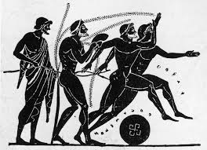
Based on the above, answer the following questions:
(a) Ancient Olympics were held in________________ , Greece.
(b) The first ancient Olympic Games can be traced back to _____________ B.C.
(c) There were a series of athletic competitions held for representatives of various city states of Ancient Greece held in honor of______________.
- ______________ of France is rightly known as the “Founder of the Modern Olympic Games’’.
OR
(d)They continued for nearly 12 centuries, until Emperor The odosius ordered in _________ A.D. to ban the Olympic Games.

SECTION—E
- Explain the aim and objectives of Adaptive physical education?
- Explain in detail the Somato types.
- Adopting illegal ways to enhance performance by taking Performance Enhancing Drugs may lead to severe side effects. List the major side effects of Doping.
- Explain in detail the Physical Education development in India after Independence.

